The Connector: Quoting and Application
GO TO: www.mahealthconnector.org Scroll down to bottom right click BROKERS GET Started
Next page scroll down to GET STARTED in green box.
Fill out next page, you must fill out tax ID, SIC CODE and put in CLIENTS email. Then CONTINUE
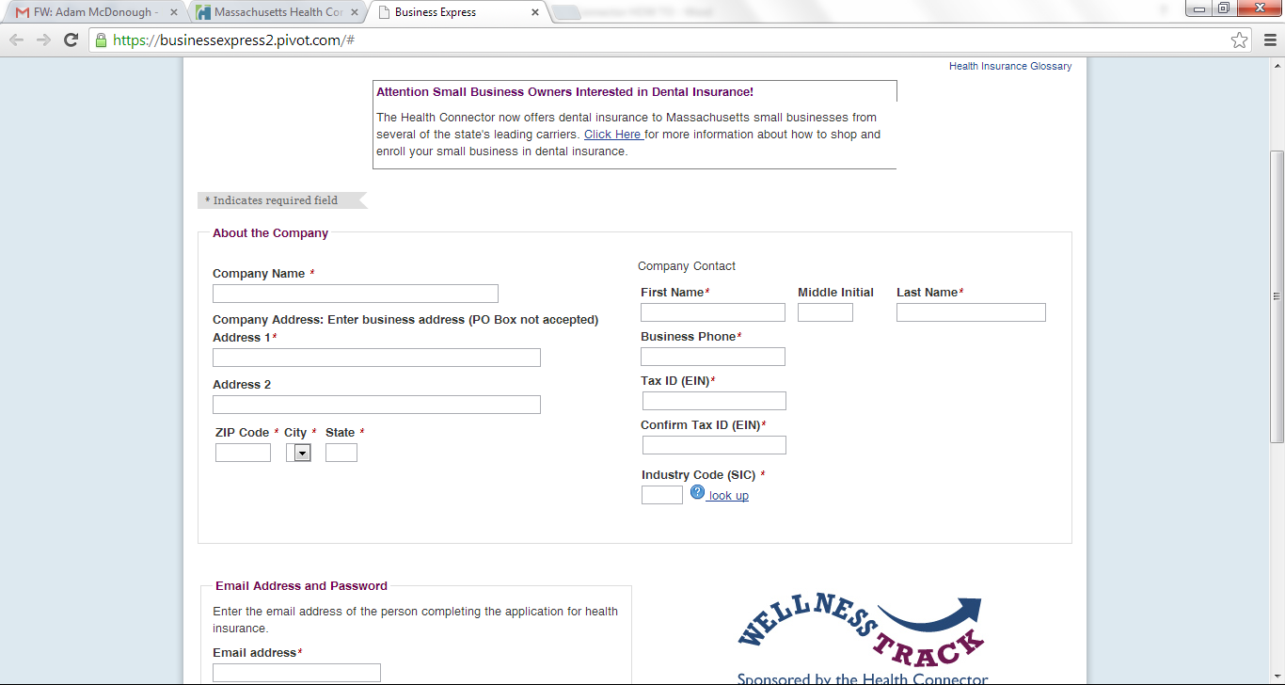

Next Page click ADD EMPLOYEE, obviously need at least 2 and 1 can waive but DO NOT PUT WAIVE-OTHER, it will not go through. If there is a waiver, you must send this in with binder check. Click CONTINUE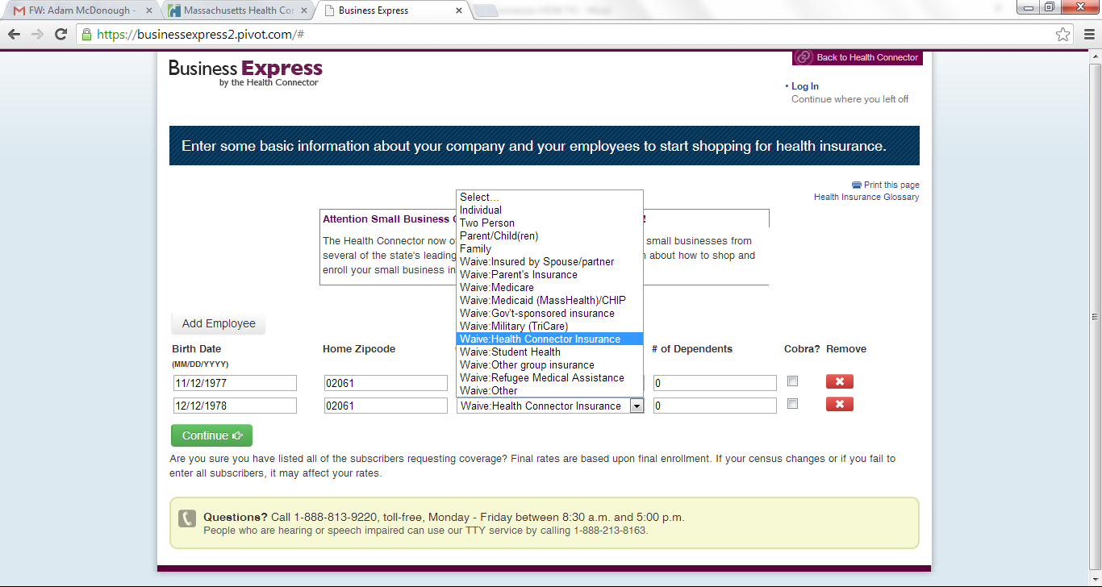
- Next page has deadline dates, click in the circle the one you want. Then CONTINUE

- Next page is ABOUT INSURANCE CARRIERS, basically useless, click CONTINUE

- Next page shows PLANS AVAILABLE, click CONTINUE to get rates

- Next page is this….. Pick the 3 you want then CONTINUE
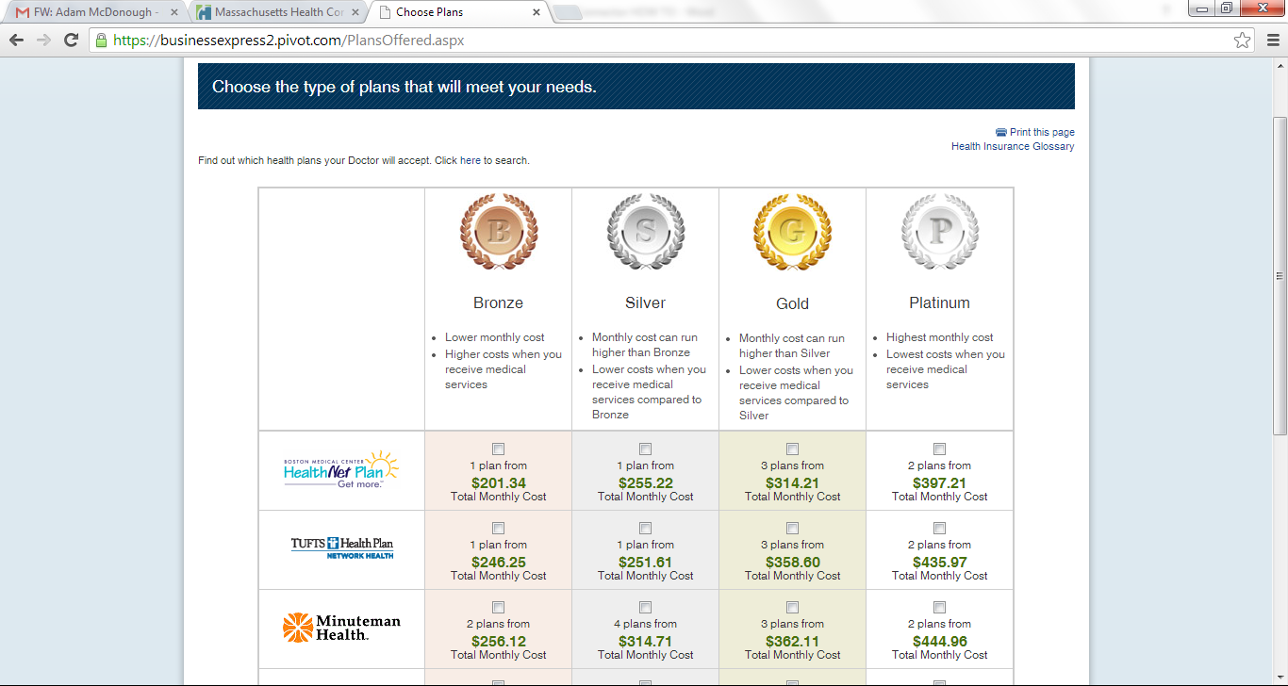
- Next page, put in employer contribution amounts, click UPDATE CONTRIBUTIONS if you changed the default numbers, this is important. Click 3 plans and COMPARE PLANS
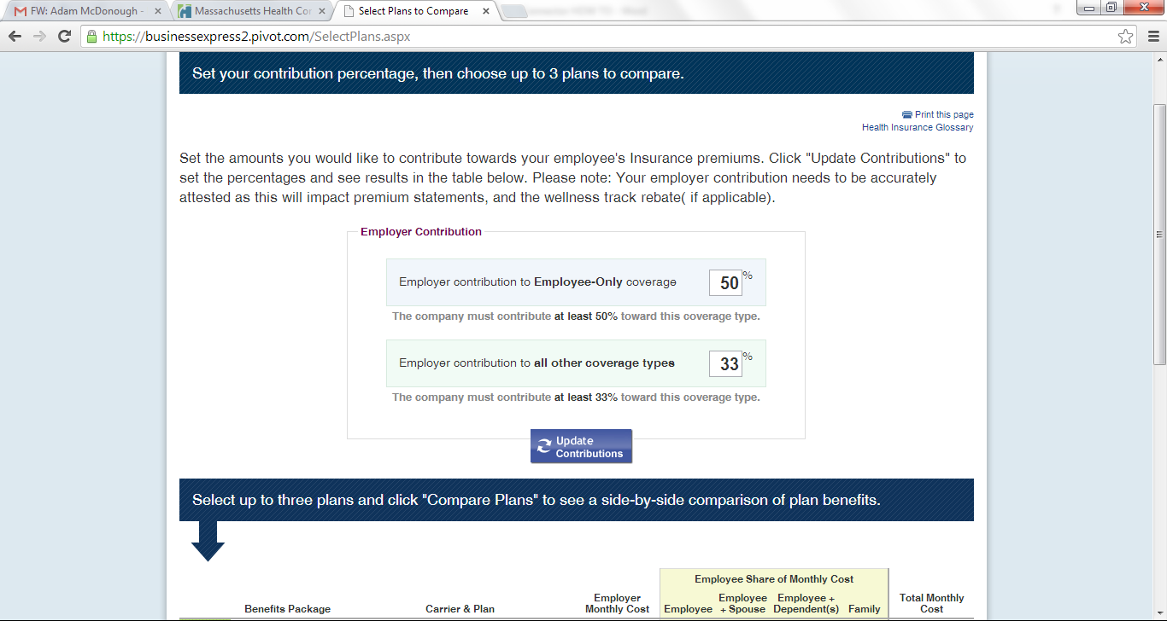

- Next page has plans selected. SCROLL DOWN TO SEE PLAN DETAILS (copays, deductibles etc.)
Then for the plan you want click CHOOSE THIS PLAN.

- Next page below “Confirm your plan” has option to SAVE FOR LATER or BEGIN ENROLLMENT
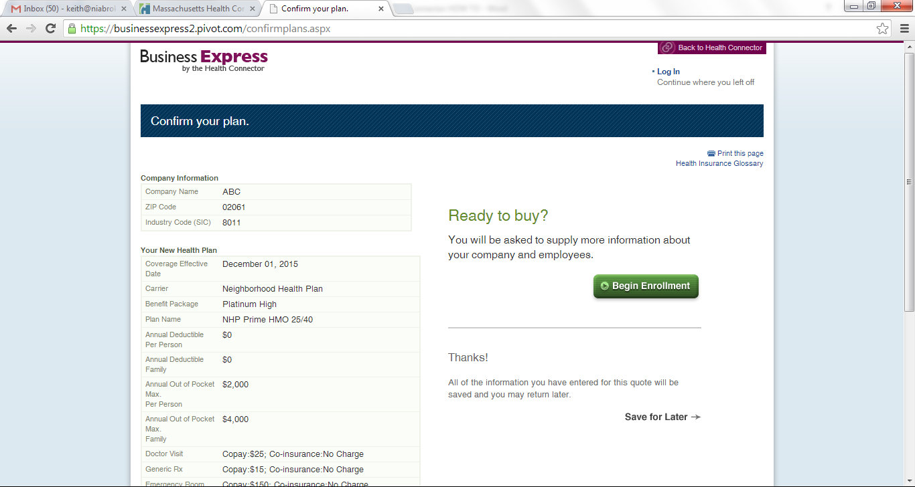

- Next Page titled “Enter information about your company”, for Broker ID put BR110001107 then your name below. Fill out rest then CONTINUE

- Next page, simply review info and put in each individuals info by clicking Edit Details then CONTINUE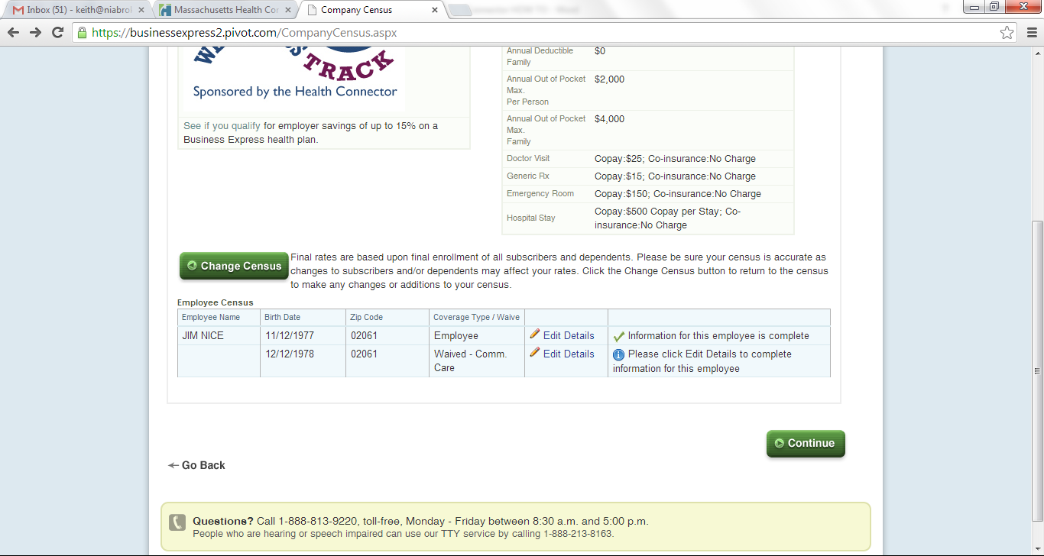

- Next page, if they want the WELLNESS TRACK, click off YES! This page will also show breakout of employer contributions.

- Then SUBMIT APPLICATION. This is final, nothing can be changed one you click this.

- Next page will show requirements necessary that need to be mailed in.

If Mike/Keith not available contact Bill at
William B. Karger
Manager of Sales & Client Services
Massachusetts Health Connector
100 City Hall Plaza, Boston, MA 02108
O: 617-933-3042
M: 617-821-9639

